A

PROJECT REPORT

ON

“Automated Server Configuration”

Submitted in the partial fulfillment of the requirement for the
Award of degree of

BACHELOR OF TECHNOLOGY
IN

COMPUTER SCIENCE & ENGINEERING


Submitted by: Under the Supervision of:
Kanhaiya Goyal
2016PUSETBCCX04654
Prateek Verma Mr. Nazrul Islam
2016PUSETBCCX04766 Asst. Professor

SCHOOL OF COMPUTER SCIENCE & ENGINEERING
POORNIMA UNIVERSITY

POORNIMA UNIVERSITY

SCHOOL OF COMPUTER SCIENCE & ENGINEERING

Certificate of Completion

This is to certify that the project entitled “Automated Server Configuration” carried out by Prateek Verma and Kanhaiya Goyal, students of bACHELOR of TechnologY (CSE) 6TH Sem, of POORNIMA UNIVERSITY, JAIPUR, RAJASTHAN, is a satisfactory account of the bonafide work under my supervision, is recommended towards the end of his/her 6th semester of B.Tech(CSE).

HOD, CSE Project Incharge

DECLARATION BY THE CANDIDATE

I, Kanhaiya Goyal, hereby declare that the project work entitled “Automated Server Configuration” is an authenticated work carried out by me at POORNIMA UNIVERSITY, JAIPUR, RAJASTHAN, for the partial fulfillment of the award of the degree of B.TECH (CSE) and this work has not been submitted for similar purpose anywhere else.

Date:
Place: kanhaiya goyal
2016BCCX1026
B.Tech. CSE 6thSem.

ACKNOWLEDGEMENT

I am thankful to Dr. Manoj Gupta, Pro-President, Poornima University, Dr. Rattan Rana, Dean, School of Computer Science & Engineering, Poornima University, and Ms. Garima Mathur, T.P.O, Poornima University for providing us with a platform to complete our project successfully.

I am also very grateful to Mr. Ravi Kumar, HOD, Computer Engineering and Mr. Nazrul Islam, Project supervisor for his constant support and counsel.

(PrateekVerma
and Kanhaiya Goyal)
2016BCCX1049
2016BCCX1026
B.Tech CSE 6th Sem

TABLE OF CONTENT

Chapter 1 Introduction

  - Aim
  - Introduction

Chapter 2 DevOps

2.1 Introduction
2.2 Industrial needs and Future Scope
2.3 Ansible
2.4 Services deployment on remote machine by Ansible
2.4.1 Web Server
2.4.2 Creating LVM partition
2.4.3 Configuring Samba Service for block sharing
2.4.4 Configuring NFS service for file sharing
2.4.5 Domain Name System Server on remote machine

Chapter 4 Conclusion

Chapter 5 References

CHAPTER-1
Introduction

  - AIM
The Aim of this project is to reflect knowledge on the basics of Linux which was also the part of our DevOps training program and in which we learned why we need to know Linux Based OS as most servers runs on Linux OS only and also how to deploy various services automatically through Ansible Playbooks

1.2 INTRODUCTION
DevOps is the future technology and every company having a software will surely work with DevOps concept. Preferred skill for the DevOps professional is communication and collaboration.

Due to competitive business advantages, DevOps has become a popular and leading technology. The organizations are even out performing through DevOps technology. Such organizations even are performing great and the new tools are also evolving in the market.

Linux is a kernel which was created by Linus Torvalds in 1991. It is a free, open source monolithic kernel which was written in c and assembly language. It is a Unix-like Operating System.

Today, Linux is used in large segments of computing world, from mobile to mainframes. According to the survey, 500 most powerful supercomputers are running on linux kernel.

The Android OS that we use in various gadgets like Tablets, Mobile phones etc. uses Linux as its kernel. Comparing to windows-

WINDOWS | LINUX
Cost is high | Free of cost
Reliability -> needs to restart after the updating | No need to restart the system after the updating, just restart the service that’s all
Innovation scope is less | High, because of it is open source
Security is low | Security is high
Hardware dependencies are high | Hardware dependencies are low
All ports are not closed | All ports can be controlled by the admin
Firewall cannot be controlled fully | We can manage the firewall manually
Ram utilization is high | Ram utilization is low

CHAPTER-2
DevOps

2.1 INTRODUCTION

DevOps is a set of practices that automates the processes between software development and IT development teams so that they can build, test and release software faster and more reliably.

It is a combination of tools, practices that increases the organization’s ability to deliver applications and services at high velocity: evolving and improving products at a faster pace than organizations using traditional software development and infrastructure management processes.

2.2 INDUSTRIAL NEEDS AND SCOPE

- Automated cloud-based testing. Security is integrated into DevOps upfront for DevSecOps.
- For big companies, which is who we focus on, renew your thinking, your processes, your architecture, and your applications. All of these make up your legacy—not just the applications.
- All need to be modernized. By renewing your thinking, I mean, embrace that you are turning into an IT company no matter what your business is.
- You’re no longer just a bank or an airline. Your software is central to the services you provide your customers. Since you’re now an IT company, you need to think about how to improve your IT processes so that they’re more streamlined, efficient, and producing value.
- Automation of application development and provisioning is a big part of efficiency and turning out better software.
- Also, look to reduce your number of applications, and use principles of modern software development to rewrite them. 80% of your code is old, never used, and is full of bugs. You need to modernize it to increase quality.
- DevOps is one area where they are watching the market and talking to start-ups. Testing, deploy management, process, security can all benefit from automation.
- Opportunity to pursue what DevOps is supposed to mean. Pursue automation. Opportunity to mingle changes in automation with the cultural change to maximize flow, feedback, and continuous improvement throughout the process so problems are solved in the process. Think about security more heavily. Making work fulfilling and rewarding.
- We’ve seen more standardization and common tooling. DevOps is becoming more precise and scientific practice. More reference cases. Learning and tooling will spread to the community. More understood as a practice, more standardize and more precise and scientific. Opportunity to do more with merging DevOps with security. Huge potential with automation and CI/CD with DevSecOps and the value of automation in the security area.

2.3 ANSIBLE
There are two types of tools present in DevOps, one is the orchestration tools and another is automation tools. Orchestration tools design the organization’s network infrastructure according to their requirements and this design is implemented with the help of automation tools such as Ansible.

Ansible is responsible for application deployment, cloud provisioning and other IT tools automatically. It works n the basis of playbook which consists of the automation task which the Ansible has to perform. Playbooks are written In the human readable, data serialization language known as YAML.
Ansible as a whole, is responsible for configuration management, i.e. it keeps the detailed information about the various hardware and software present or used by the Enterprise Network. Such as what version and updating the software has grown through, their location and the IP addresses of all the hardware present in the network.

FEATURES:

- Agentless-
    - Other automation tools like chef and puppet works on the basis of pull architecture. That means, in order to manage the hosts through the control node, first we need to install the chef client or puppet agent on all the hosts in the network individually to manage them from the single place.
    - These agents keep on pinging the server or control node for any change configuration script file, if any, they pull that script form the control node and run that in their respective hosts.
    - On the other hand, Ansible works on the basis of push architecture. That means, control node pushes the change configuration script file automatically to the hosts via ssh, no software or the agent is required to be installed on the network hosts for the updating process.

- SSH-
    - We can establish the connection between the host and the control node with the help of SSH which has the facility for the key-based authentication. All the hosts need to do is to create the public key and copy it to the control node so that they can authenticate over the network through the public keys.

- PUSH-
    - Works on push architecture, no agent or software is needed to deploy on the hosts for any scripts required to run.

WORKING:

Ansible involves four things - Playbook, Inventory, API and Plugin. Suppose I need to install the web server on the hosts. So I will enter the IP addresses of all those hosts in the inventory file and will create the playbook for the installation. Control node will send the playbook on the addresses which are mentioned in the inventory file. The script, after successfully execution, will get deleted form the hosts automatically. They are transferred via SSH.

WORKING THROUGH DIAGRAM:

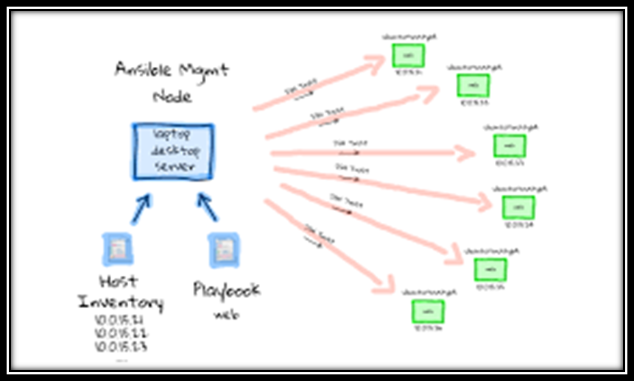

INSTALLATION:

- Control node has Linux OS always, hosts can either be windows or Linux

- On control node, first of all, install the epel repository-
    - Yum install epel-release –y

- Now check the verison for the python. Should be 2.7-
    - Python –version

- Now install the ansible version 2.6 is latest-
    - Yum install ansible* -y

2.4 Services deployment on remote machine by Ansible

2.4.1 Web Server

Today, Apache is the commonly used Web Server on Linux based systems. When we talk about Web Servers, they are used to serve Web pages which are requested by the client computers over the network. Clients, then, can access the web pages through their browsers like Firefox, Chrome etc.

Browsers provide access to the pages by using different protocols or the set of rules responsible for it like, Hyper Text Transfer Protocol (HTTP), secure version of HTTP (HTTPS), and File Transfer Protocol (FTP). These protocols provide features like uploading and downloading contents over the network. Apache is a powerful and robust platform for development and deployment of web-based applications.

First, we will create the playbook file for the deployment of webserver on remote machines with the command ---

vim playbook.yml

Then, will will type the script written below---

- hosts: webserver
user: root
vars:
motd_welcome: 'welcome to Grras\nLive, Love, Learn Linux\n'
tasks:
- name: sample motd
copy:
dest: /etc/motd
content: "{{ motd_welcome }}"

configuring apache

---
- hosts: webserver
user: root
tasks:
- name: copy repo file
copy: src=apache/rhel.repo dest=/etc/yum.repos.d/rhel.repo
- name: installing httpd
action: yum name=httpd state=installed
- name: copy index.html
copy: src=apache/index.html dest=/var/www/html/index.html (content of index.html == <html>\n<h1>\napache configured using ansible\n </h1>\n</html>)
- name: start apache service (httpd.service)
service:
name: httpd
state: restarted

- hosts: webserver
user: root
vars:
motd_welcome: 'welcome to Grras\nLive, Love, Learn Linux\n'
tasks:
- name: sample motd
copy:
dest: /etc/motd
content: "{{ motd_welcome }}"

configuring apache

---
- hosts: webserver
user: root
tasks:
- name: copy repo file
copy: src=apache/rhel.repo dest=/etc/yum.repos.d/rhel.repo
- name: installing httpd
action: yum name=httpd state=installed
- name: copy index.html
copy: src=apache/index.html dest=/var/www/html/index.html (content of index.html == <html>\n<h1>\napache configured using ansible\n </h1>\n</html>)
- name: start apache service (httpd.service)
service:
name: httpd
state: restarted

Now, run this playbook to deploy the service on the remote machine by the command---

ansible-playbook playbook.yml

Now, we go to client mchine just to check the webpage is opening or not.

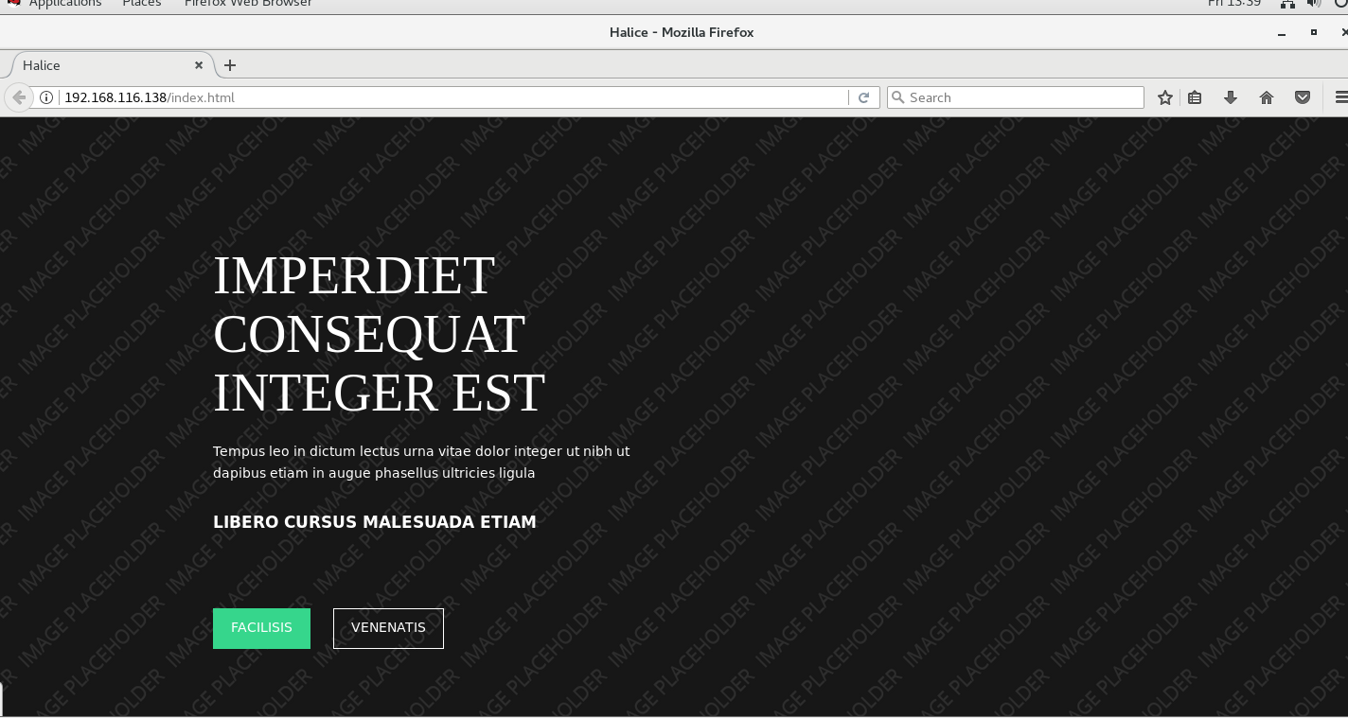

2.4.2 Creating LVM partition

Create a playbook file by ---

vim playbook.yml

and type the following script to create a LVM partition—

---
- hosts:
user: root
tasks:
- name: vgcreate
lvg:
vg: myvg
pvs: /dev/sdb1,/dev/sdb2 (this needs to be created manually)
- name: lvcreate
lvol:
vg: myvg
lv: mylv
size: 1500M
- name: create file system
filesystem:
fstype: ext4
dev: /dev/myvg/mylv
- name: mount logical volume
mount:
name: /mylv
src: /dev/myvg/mylv
fstype: ext4
state: mounted

Now, run this playbook to deploy the service on the remote machine by the command ---

ansible-playbook playbook.yml

2.4.3 Configuring Samba Service for block sharing

It is a server and client software to interoperate with the windows machine.
It runs on the port number 445 which is a tcp port. In Linux, its service is samba.service and it works on CIFS (Common Internet File System) for windows to windows communication.

It is open source which can share the files from Linux to windows based OSs. It has two more services SMB and NMB .SMB is responsible for sharing the partition formatted with types not supported by windows OS and NMB handles NETBIOS and WINS.

Both NETBIOS and WINS are used to share the partition between windows machines and they both are managed by NMB.

Create a playbook file by ---

vim playbook.yml

Now, type the following script for samba configuration—

- Hosts: client
Tasks:
- Name: install samba pkgs
Yum:
Name: “{{lists}}”
State: latest
Vars:
Lists:
Samba
Samba-client
Samba-python
Samba-windbind
Name: create directory
File:
Path: /private
State: directory
Mode: 0755

Name: service start and enable
Service:
Name: smb
State: started
Enabled: yes
Name: service start and enable
Service:
Name: nmb
State: started
Enabled: yes

Now in order to deploy samba server on remote machines, run the following command---

Ansible-playbook playbook.yml

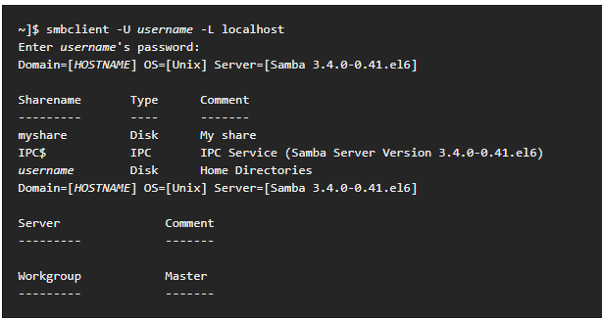

2.4.4 Configuring NFS service for file sharing

Network File System (NFS) is a popular distributed filesystem protocol that enables users to mount remote directories on their server.

NFS lets you leverage storage space in a different location and allows you to write onto the same space from multiple servers or clients in an effortless manner.

Create a playbook file by ----

vim playbook.yml

Now, write the script for automation deployment—
- Hosts: webservers
Tasks:
Name: create directory
File:
Path: /
State: directory
Mode: 0755
Name: install infinisdk
Yum:
Name: infinisdk
State: latest
Name: configuration
Infini_export_client:
Client: 192.168.1.42
Access_mode: RW
No_root_squash: no
Export: /data
User: root
Password: secret
System: ibox001

Now, to deploy nfs on client machine through playbook file----

Ansible-playbook playbook.yml

2.4.5 Domain Name System Server on remote machine

Domain name system also known as DNS plays a very important role. Since we know that each and every website present over the internet has its own IP address, but remembering all those addresses is impossible for the human being.

So in order to make the task simpler, DNS was introduced. It resolves the name of the website you have entered in the browser to its corresponding IP address and vice versa.

There are ways by which the DNS resolves the queries-

Recursive:

Suppose the client types the google.com on its browser’s url box, this query will go to corresponding ISP. First it will go to the root server, root will give ISP the IP of .com server, then .com server will give ISP the IP of google server and google will tell ISP its IP which the ISP will store it in the cache and send it to the client

To configure DNS via playbook file---

vim playbook.yml

Now, type the script for automated deployment of server---

- Hosts: webserver
Tasks:
Name: pkg install
Yum:
Name: bind
State: latest
Name: named.conf
Lineinfile:
Path: /etc/named.conf
Insertafter: ‘options {‘
Regexp: ‘listen-on port 53 { 127.0.0.1; };’
Line: ‘listen-o port 53 { 192.168.1.42; };’
Name: add zone
Lineinfile:
Path: /etc/named.conf
Line: ‘zone “grras.com.” { type master; file “forward” };’

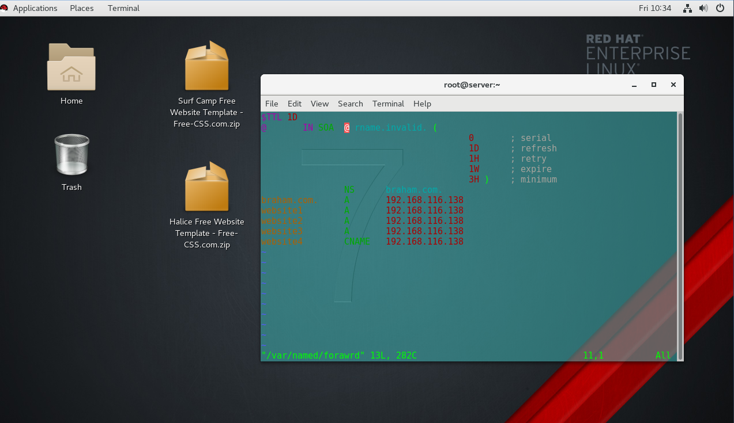

Chapter 4 Conclusion

I learned the use of Ansible tool for automating the tasks on several machines at the same time. Also learned core python for creating and performing scripts.
Learned about the working of Ansible. It involves four things - Playbook, Inventory, API and Plugin. Suppose I need to install the web server on the hosts. So I will enter the IP addresses of all those hosts in the inventory file and will create the playbook for the installation. Control node will send the playbook on the addresses which are mentioned in the inventory file. The script, after successfully execution, will get deleted form the hosts automatically. They are transferred via SSH.

Chapter 5 References

I have created this report on the basis of my learning during the training period, with some help from my trainer and also took the material from handwritten notes which I prepared during the training.

